

**Climate Change Analysis Project**

**GROUP-1**

**Sravya Sri Sada**

**Shasheel Ramaswamy Shaker Dasari**

**Bal Thirupathi Guddati**

**Parthu Thulasi**

**Sandeep Chanda**

**Professor: Kenneth Desloover**

**BIS580- Business Decision Modeling**

**Class: 22456368**

**Table of contents**

Executive Summary1

Introduction 1

Problem Statement 2

Analysis2

Forecasting 2

Descriptive statistics 3

Correlation 4

Anova:Single Factor 5

Linear Regression 5

Sensitivity Analysis 6

Recommendations 7

References 8

**EXECUTIVE SUMMARY:**

Scientists constantly study and monitor phenomena, its causes, and its consequences; at the time, climate change is one of the most pressing issues getting the most attention. This irreversible environmental condition might have long-term effects on the planet's present and future. Human activities, such as the overuse of non-renewable resources and the release of greenhouse gases into the atmosphere, are to blame for climate change.

We had used diverse analytical tools such as forecasting, descriptive statistics, correlations, ANOVA analysis, linear regression, and sensitivity analysis. The research highlights impending CO2 emissions, the diverse nature of energy sources, the complex interrelations among them, and their profound impact on climate variables.

Key findings underscore the imminent rise in CO2 emissions, necessitating immediate interventions while offering hope through potential emission reduction strategies. Descriptive statistics emphasize the distinct nature of energy sources, with renewables standing out for higher mean values and greater variability. Correlations reveal intricate relationships between traditional and renewable energy sources, guiding strategic decisions.

The ANOVA analysis confirms significant differences among energy categories, emphasizing the need for tailored policy approaches. A robust linear regression model with a high R-squared value showcases the substantial impact of energy sources on climate variables. Sensitivity analysis provides critical insights into potential temperature trends based on varying policy scenarios.

**INTRODUCTION:**

Climate change is perhaps one of the major global challenges of our day. Scientists have been observing and researching climate change and its numerous causes for an ongoing period. Since climate change is unavoidable, it is our responsibility to learn how to keep our environment as safe as possible for both the present and the future. It has been observed that human activity is one of the several causes of the climatic variations on Earth. "Burning fossil fuels, such as coal, oil, and natural gas," an article claims. When these materials burn, greenhouse gases are released into the atmosphere of Earth. There, these gases cause the Earth's average temperature to rise by trapping heat from the sun's rays inside the atmosphere (National Geographic Society, 2022)

The task at hand concerns environmental policies by 2100, we must set a goal temperature increase of no more than 2 degrees Celsius while limiting the average temperature. Our plan is to employ various decision support tools and important inputs to assist and graphically represent the policy changes we advocate. Using analytical methods, we will present our findings and go over important presumptions about nuclear energy and coal production, which have an influence on temperature changes, and natural gas, which has little to no effect on temperature fluctuations. The analysis models will describe the steps and apply our conclusions in the next parts so that we may reach the requested temperature.

**Problem Statement (Purpose):**

Immediate action is imperative to address the escalating threat of climate change, primarily driven by human activities like excessive non-renewable resource consumption and greenhouse gas emissions. This study aims to formulate strategies to cap the Earth's atmosphere at a two-degree Celsius increase by 2100 year, crucial for averting severe consequences and preserving the planet's health for current and future generations.

Leveraging various statistical tools and decision-making techniques, the study takes a comprehensive approach, analysing variables such as CO2 reduction, energy efficiency in transportation and buildings, carbon pricing, oil taxation, coal production, and their intricate interconnections. This analysis aims to discern their direct impact on temperature fluctuations and, consequently, on climate change.

**Analysis:**

**Forecasting:**

Forecasting is the strategic practice of projecting future trends or outcomes by analysing historical and current data. This essential tool finds application across diverse domains, including finance, economics, business operations, and weather prediction.

The above graphs show the baseline and current scenario CO2 values forecasted using an exponential smoothing constant of 0.6. The baseline forecast shows a steady increase in CO2 values, while the current scenario forecast shows an initial increase followed by a decrease. This suggests that even without intervention, CO2 emissions are expected to rise in the future. However, the current scenario forecast indicates that it is possible to reduce emissions through significant changes.

These graphs provide valuable information for policymakers and stakeholders working to address climate change. The baseline forecast highlights the urgency of action, while the current scenario forecast offers hope that emissions can be reduced through effective policy measures.

**Descriptive statistics:**

Descriptive statistics encompass a collection of metrics utilized to condense and illustrate the principal characteristics inherent within a dataset.

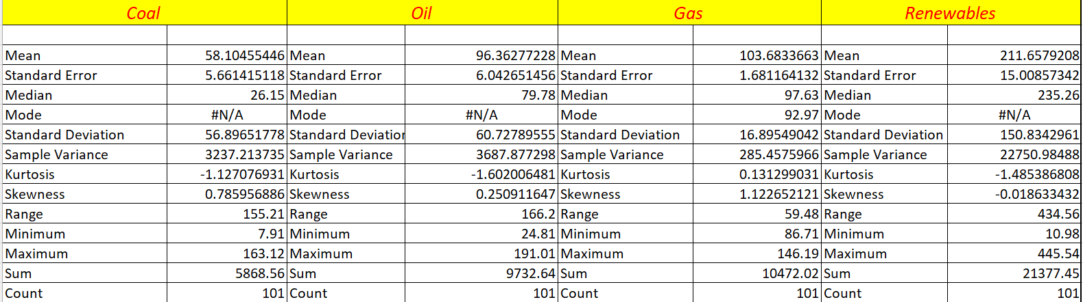

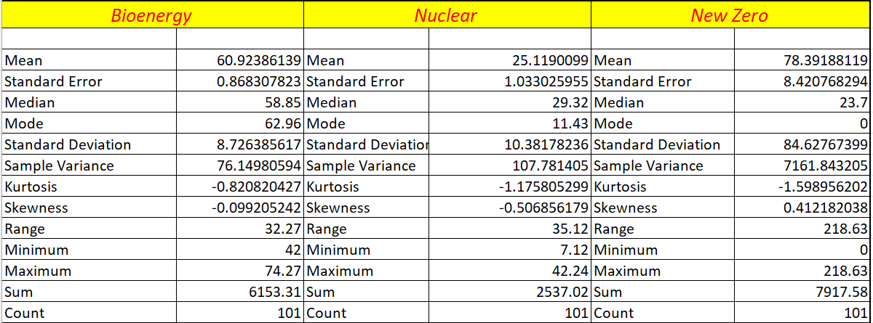

The mean values depict the average quantities for each source, where renewables notably display a considerably higher mean compared to the other sources.

Standard deviation and variance highlight the degree of variability within each energy type, with renewables demonstrating the highest deviation.

Skewness and kurtosis indicate the distribution's shape and whether it deviates from a normal distribution; for instance, gas displays positive skewness, signifying a distribution skewed to the right.

The range provides an understanding of the spread between the minimum and maximum values, showcasing the variability within each energy source. Additionally, details like mode, median, and specific minimum and maximum values offer further insights into the central tendency and extremities of the data for each energy category.

**Correlation:**

A correlation is a statistical measure that reveals how closely and in what manner one variable changes concerning another.

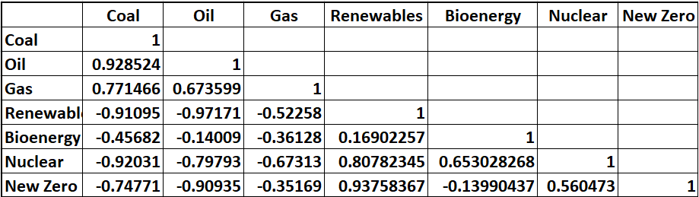

The correlation matrix reveals strong positive associations between coal and oil, gas and oil, and gas and renewables. Conversely, negative correlations exist between renewables and traditional sources like coal, oil, and gas. This insight into energy relationships can guide decisions on diversification strategies, investment strategies in the energy sector.

**Anova-Single Factor:**

**Null Hypothesis (H0):** The means of coal, oil, gas, renewables, bioenergy, nuclear, and new zero are equal; there is no significant difference in the average values among these groups.

**Alternate Hypothesis (H1):** There is a significant difference in the mean values among the coal, oil, gas, renewables, bioenergy, nuclear, and new zero energy categories.

The ANOVA analysis indicates a significant difference between at least one pair of energy groups. The low p-value suggests strong evidence against the null hypothesis, implying that the means of these energy categories are not all equal. Therefore, based on this analysis, we can reject the null hypothesis and conclude that there are significant differences among the mean energy values of the coal, oil, gas, renewables, bioenergy, nuclear, and new zero categories.

**Linear Regression:**

Linear regression analysis is used to predict the value of a variable based on the value of another variable. The variable you want to predict is called the dependent variable. Several statistical approaches are used in the study's strong analytical framework to fully comprehend the dynamics of climate change and how it relates to important variables.

Absolutely, the R-squared value of 0.9998 suggests that the variations in the dependent variable are strongly associated with changes in the energy types of coal, oil, gas, renewables, bioenergy, nuclear, and new zero. This high value implies that about 99.98% of the variability in the outcome can be accounted for by fluctuations in these energy sources. Therefore, this regression model serves as a valuable tool for understanding how these diverse energy categories impact the dependent variable.

**Sensitivity Analysis:**

Sensitivity analysis is a technique used to understand how changes in different variables impact the outcome of a particular model, system, or decision-making process.

The above graphs illustrate how the alterations in these scenarios impact temperature trends over time. The data illustrates a consistent progression, indicating higher temperatures in scenarios with a 10% increase compared to the current and baseline temperatures. Conversely, scenarios with a 10% decrease show lower temperatures. A comprehensive view of how these scenarios might influence temperature changes, offering insights into potential future temperature trends based on the defined alterations.

**Recommendations:**

To mitigate greenhouse gas emissions, prioritize reducing deforestation, increasing afforestation, and embracing new technology. Manage population and economic growth, keeping them in check. Decrease reliance on major fossil fuels like carbon and coal to curb greenhouse gases. Our model predicts a 1.9-degree Celsius temperature rise by 2100 with these adjustments, reinforcing the necessity of these recommendations.

Develop and implement robust policies aimed at reducing CO2 emissions, focusing on interventions that effectively target the sources identified as significant contributors. Emphasize strategies to promote renewable energy sources given their higher mean values and potential for variance, thus reducing reliance on traditional fossil fuels.

Employ sensitivity analysis findings to inform climate mitigation strategies. Focus on scenarios with decreased emissions and explore measures to achieve these reductions, acknowledging the potential impact on future temperature trends.

**References**

Evans, J. R. (2019). Business Analytics (3rd ed.). Pearson Education (US). <https://online.vitalsource.com/books/9780135231906>

En-ROADS Climate Scenario. (n.d.). En-Roads.climateinteractive.org. from<https://enroads.climateinteractive.org/scenario.html?v=23.12.0&p1=45&p196=50&p202=2030&p7=24&p212=50&p16=-0.04&p20=2031&p30=-0.07&p35=2&p39=123&p41=5&p57=-10&p65=81&p218=5&p219=6&p67=37>

Hayes, A (2023). Descriptive Statistics: Definition, Types, Overview, Examples. Investopedia. <https://www.investopedia.com/terms/d/descriptive_statistics.asp>